Statistics
First Name, Middle Initial(s), Last Name
Author's Affiliation
Course Number and Name(s)
Instructor's Name
Assignment Due Date

Statistics
Different terms feature in statistics. A variable in statistics can be defined as anything that can be quantified, counted or measured. A variable is also referred to as a data item. Examples of variables are sex, expenses, grades, capital, expenditure, vehicles, motorcycle, and animals. Variables may vary between data units in a given population and are prone to change over time (Elliott & Valliant, 2017). There are two types of variables, and they are discrete variables and continuous variables. A continuous variable can take any value between a set of real numbers, and it is also called a numeric variable. Some examples of continuous variables include; temperature, time, height.
On the other hand, a discrete variable takes whole numbers and cannot take fractions. Examples of discrete numbers include no cars, individuals attending a meeting etc. Data is a unique measurement of a variable, and you record data in your datasheet. There are two categories of data, and they include; categorical and quantitative data. Categorical data represent groupings in statistics. Quantitative data will represent the amount.
Quantitative data represent numbers that are real, and they can be divided, added, subtracted etc. quantitative data is either continuous or discrete. A categorical variable is used to represent grouping. Categorical variables are sometimes recorded as numbers, but these numbers will then represent categories rather than the actual amount of items. Categorical variables are then divided into three categories: ordinary categorical variables, nominal categorical variables, and nominal categorical variables. Binary categorical variables the expected outcomes are YES/No; an example is when you toss a coin, the expected output is either ahead or tail outcome. Ordinary variables represent data groups ranked in a specific order; an example is the rating scale in a given survey. On the other hand, Nominal variables represent data that is not ranked in any specific data, an example, brands (Heeringa et al., 2010).

Other terms that are related to statistics include; population, statistic, parameter and sample. In statistics, a population is a group of people, items, or things you want to study. For example, you may decide to study the effects of COVID 19 on blood sugar levels. The population will be individuals whom you want to test and obtain your results. A sample is a subset of your population; for example, in a town of 100,000 people, it may become difficult to test every individual to pick 500 individuals from the 10,000. The 500 selected are the sample size. A parameter is the trait of the population that you are interested in your test or estimation. A statistic is the quantitative trait of your sample, and it aids the estimate of the population parameters (Jones, 2015).
Descriptive statistics are singular results that you obtain when you analyze a set of data. Descriptive statistics are median, sample means, test statistic, regression line, standard deviation, and standard deviation. Statistical inference is making a conclusion based on your data and its descriptive statistics and conclusion about the test population. There are several types of inferences, including hypothesis tests, regression, intervals, and confidence. Statistics are used to design and analyze sample surveys. Classical methods can also be used, for example, using ranks to improve estimates collected from sample surveys. Survey methods can also improve on interval estimates collected from sample surveys (Peherstorfer et al., 2018).

I have decided to discuss the topic of Sampling Estimation & Survey Inference. Survey sampling is very important as it has many application areas in our country and worldwide. Sampling estimation and survey, for example, are used by the government when conducting the census. Sampling helps cost-effective and timely estimates of the population in our country. Demographics is an example of sample surveys picked during a census. These demographic samples estimates provide information about individuals, for example, level of educational attainment, employment, health insurance, poverty levels and health insurance. The government can use this information to see what areas to improve on. For example, suppose in a particular state, the number of individual with no health insurance is high. In that case, the government can develop initiatives to make health insurance accessible to the general public. Suppose the data obtained from another state has a high number of unemployed people. In that case, the government can develop strategies to create employment opportunities in the state so that people gain employment.
Businesses can also do economic sample surveys on inventories, sales, production, revenue, and payrolls. Once a business has obtained this information, they can make the necessary predictions on the expected financial position of the business in the future, projected sales and so on. How to design and analyze samples of your survey from your data is determined by some non-probabilistically sampled data to achieve a representative population coverage. You can make your survey data products based on administration, and your survey data will be representative of the general population. The survey question I intend to answer is how I can use Sampling Estimation & Survey Inference to estimate the effects of Covid on income for individuals in my city. The research aims to answer the question of whether there has been a rise or decline in the levels of income of individuals after Covid 19 struck.
The research will start by identifying a group of individuals who are willing to give details on their salaries and income. The next point is preparing some questionnaire questions that you will give to your selected participants to find out their current salaries and previous incomes before Covid 19 struck. The population is individuals who are currently working and being paid. Still, since not everyone can be interviewed, I have to select a sample size of about 1000 individuals as a researcher. After data collection, I will have to select a formula that will help me develop a statistical inference or conclusion. In statistics, five standard methods can be used for statistical analysis. These methods include the mean or average method, the regression method, Hypothesis Testing, Sample Size Determination and standard deviation. The mean method is also known as the average; it is the sum of total items in the list divided by the number of items in your list. The advantage of this method is that it is easy to calculate, and it is easy to determine the overall trend of your data. The formula for mean is
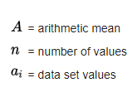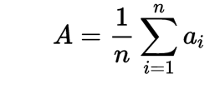
The following formula is the standard deviation and is used to measure the spread of data around the mean data. The standard deviation method is helpful for the fast determination of the dispersion of data points. If you have a high standard deviation, it means that your data is spread widely from your mean. A low standard, your data is more aligned to the mean. The formula for standard deviation is
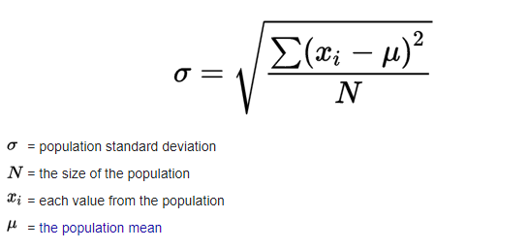
The regression method is used to model the relationships amongst explanatory and dependent variables that are usually chattered on a scatterplot. Regression determines whether relationships are weak or strong; the method for regression is
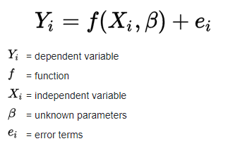
The hypothesis testing formula determines if a given premise is true or false in your data. Hypothesis tests are essential because they are used in many application areas. The best formula to use in my scenario is the standard deviation formula. You can easily define whether there has been an increase in wages or a reduction in wages after COVID 19.

References
Dillard, J. (n.d.). 5 most important methods for statistical data analysis. https://www.bigskyassociates.com/blog/bid/356764/5-Most-Important-Methods-For-Statistical-Data-Analysis
Elliott, M. R., & Valliant, R. (2017). Inference for Nonprobability samples. Statistical Science, 32(2). https://doi.org/10.1214/16-sts598
Heeringa, S. G., West, B. T., & Berglund, P. A. (2010). Applied survey data analysis. https://doi.org/10.1201/9781420080674
Jones, A. (2015). A disciplined approach to critical thinking. The Palgrave Handbook of Critical Thinking in Higher Education, 169-182. https://doi.org/10.1057/9781137378057_11
Peherstorfer, B., Willcox, K., & Gunzburger, M. (2018). Survey of Multifidelity methods in uncertainty propagation, inference, and optimization. SIAM Review, 60(3), 550-591. https://doi.org/10.1137/16m1082469
US Census Bureau. (2020, August 31). Sampling estimation & survey inference. The United States Census Bureau. https://www.census.gov/topics/research/stat-research/expertise/survey-sampling.html

